**Community82 (Team 82) Source Code and Website Link**

***Website:*** [***http://54.206.25.253/pages/index.php***](http://54.206.25.253/pages/index.php)

***Team 82 GitLab Link:*** [***https://gitlab.com/IFB299Group82/IFB299Group82.git***](https://gitlab.com/IFB299Group82/IFB299Group82.git)

* Source Code:
  + Each piece of code is also included in GitLab under ‘SecondRelease’ and ‘SourceCode’
  + Individual files denote which section of the website the code represents and relates to
  + A copy of the SourceCode.zip has also been provided in the Blackboard submission
* Website:
  + Website link is provided above (also refer to GitLab for more details)
  + Screenshots of the main elements of the website are illustrated below:
* Logins for Website:
  + For General Member:
    - Username ‘test3’ and Password ‘12345678’
  + For Volunteer:
    - Username ‘vol1’ and Password ‘12345678’
  + For Committee Member:
    - Username ‘com2’ and Password ‘12345678’
  + For Admin:
    - Username ‘admintest’ and Password ‘12345678’

***HOME PAGE:***

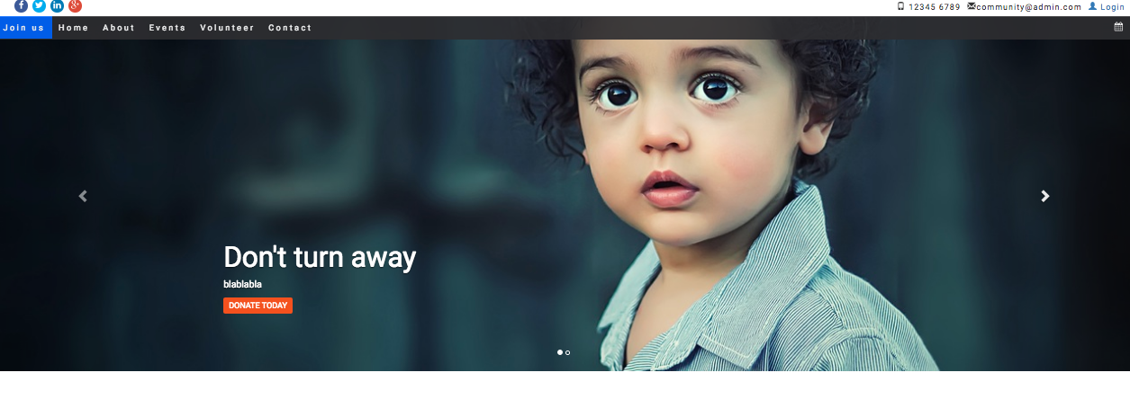

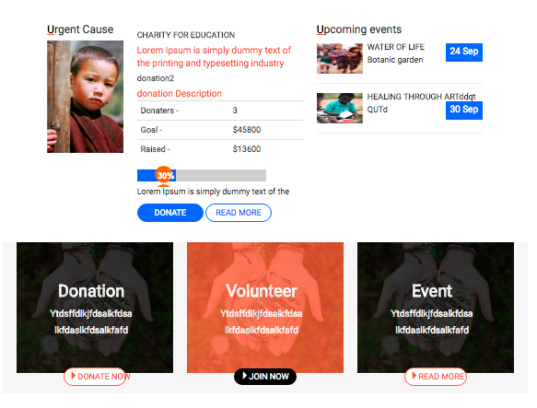

***JOIN US - GET INVOLVED:***

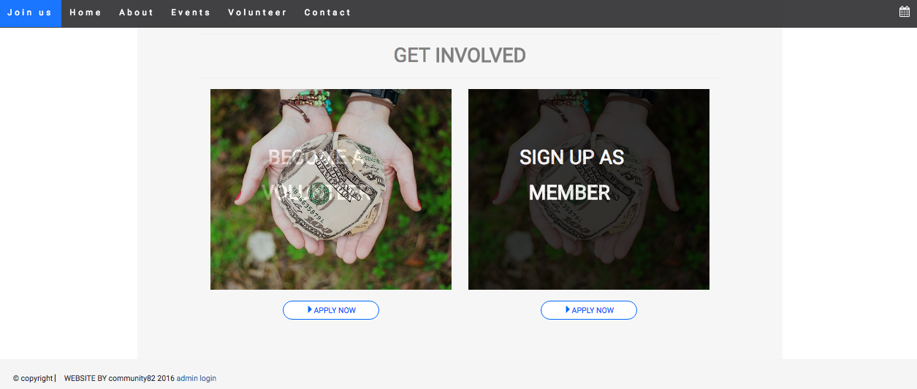

***BECOME A MEMBER - SIGN UP:***

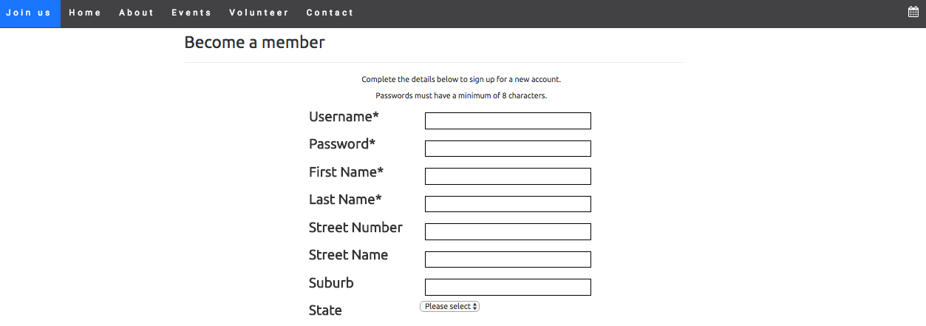

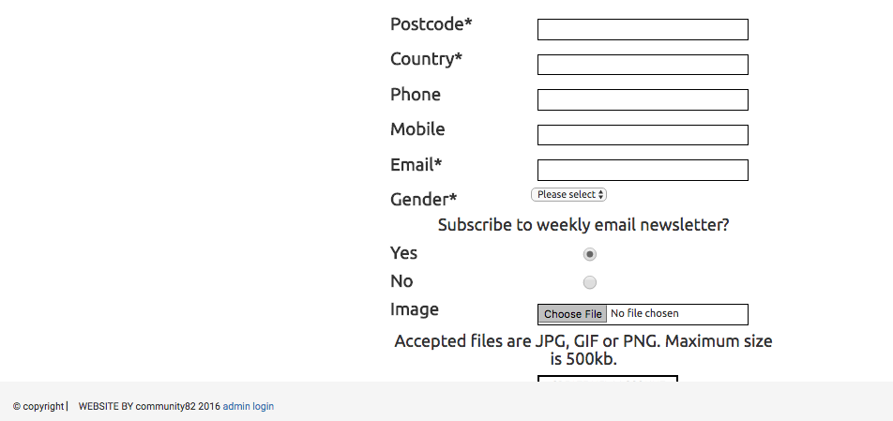

***BECOME A VOLUNTEER - SIGN UP:***

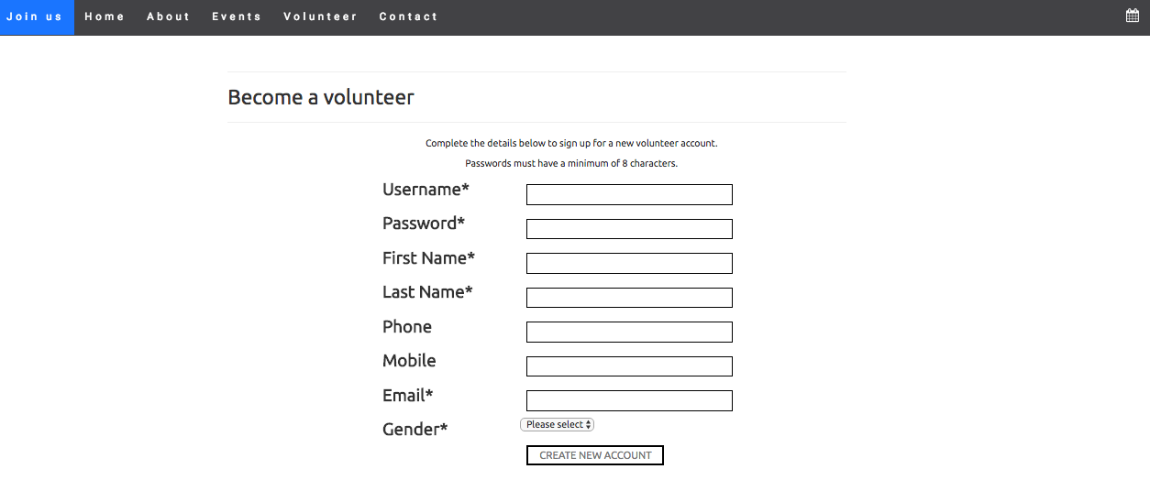

***LOGIN SCREEN:***

* For General Member: Username ‘test3’ and Password ‘12345678’
* For Volunteer: Username ‘vol1’ and Password ‘12345678’
* For Committee Member: Username ‘com2’ and Password ‘12345678’

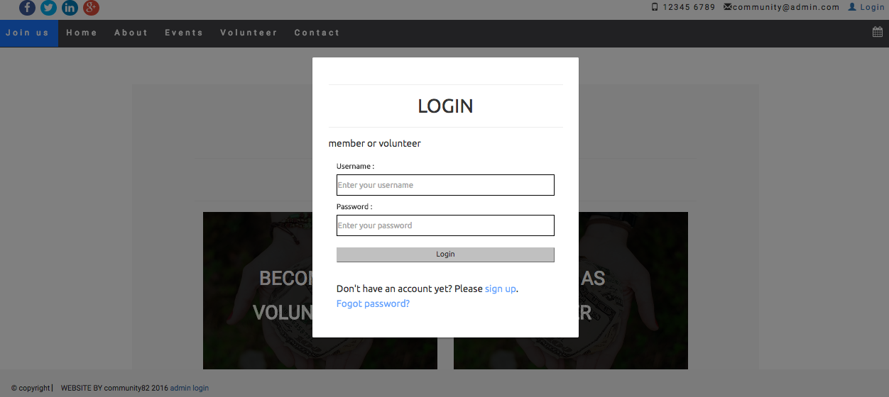

***GENERAL MEMBERS - EVENTS HOMEPAGE:***

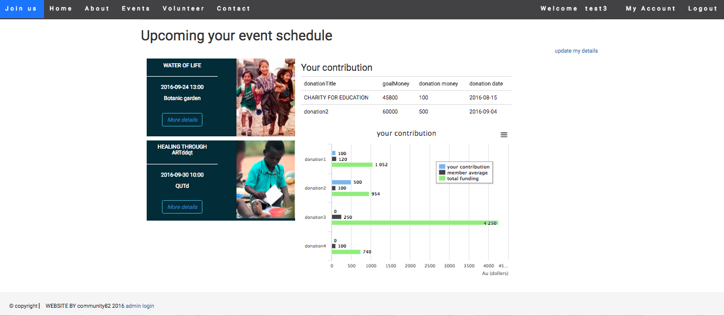

***GENERAL MEMBER - UPDATE ACCOUNT DETAILS:***

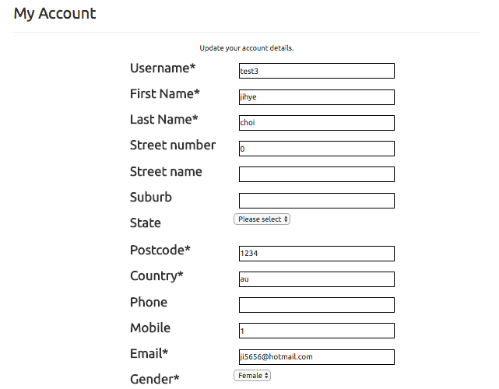

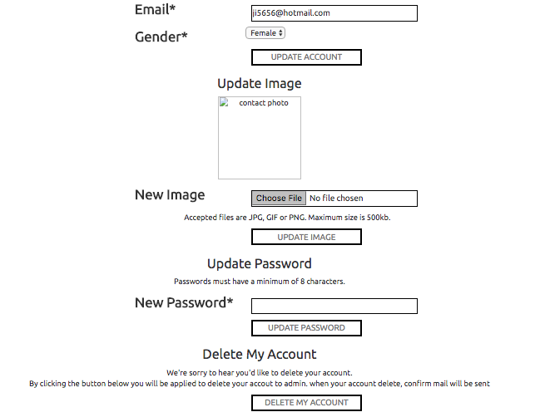

***VOLUNTEER - MY ACCOUNT:***

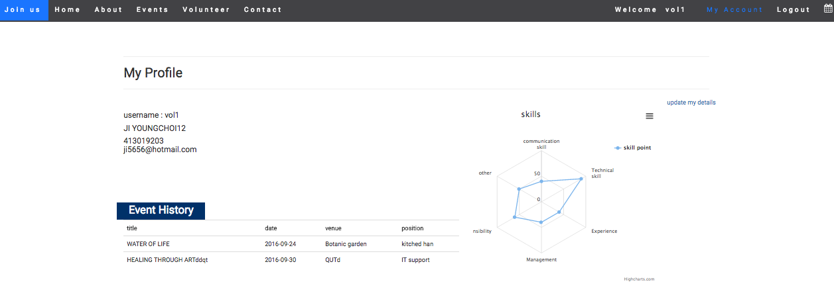

***COMMITTEE MEMBERS - MANAGE EVENTS:***

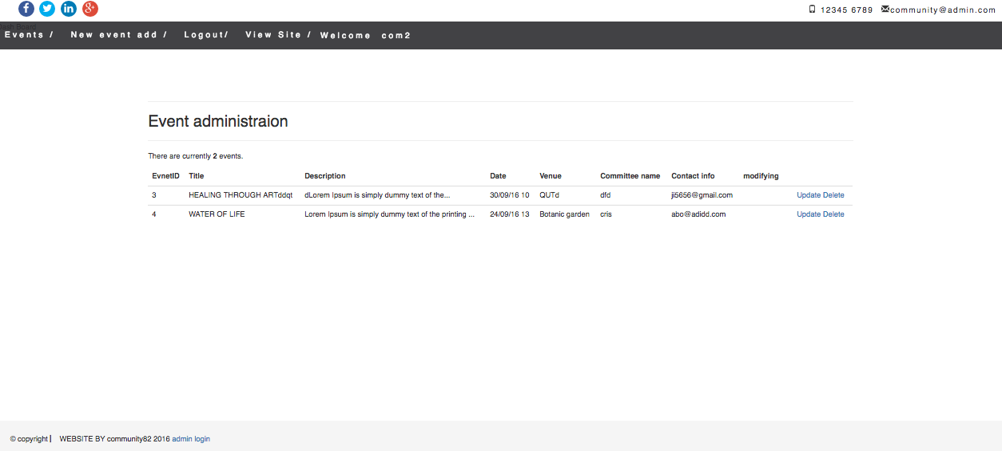

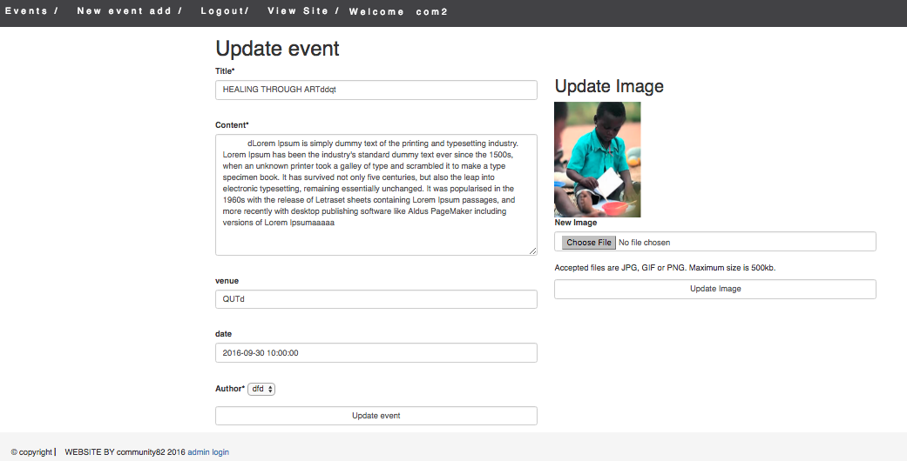

***UPCOMING EVENTS:***

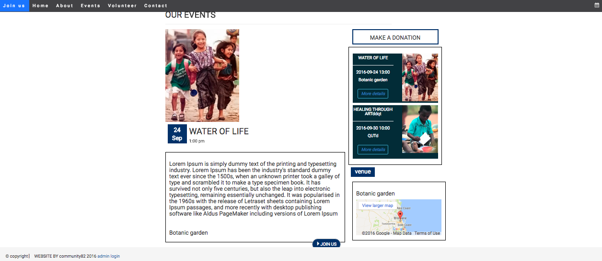

***ADMIN LOGIN:***

* For Admin: Username ‘admintest’ and Password ‘12345678’

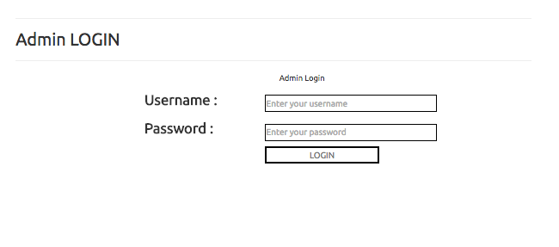

***ADMIN - MEMBER MANAGEMENT:***

